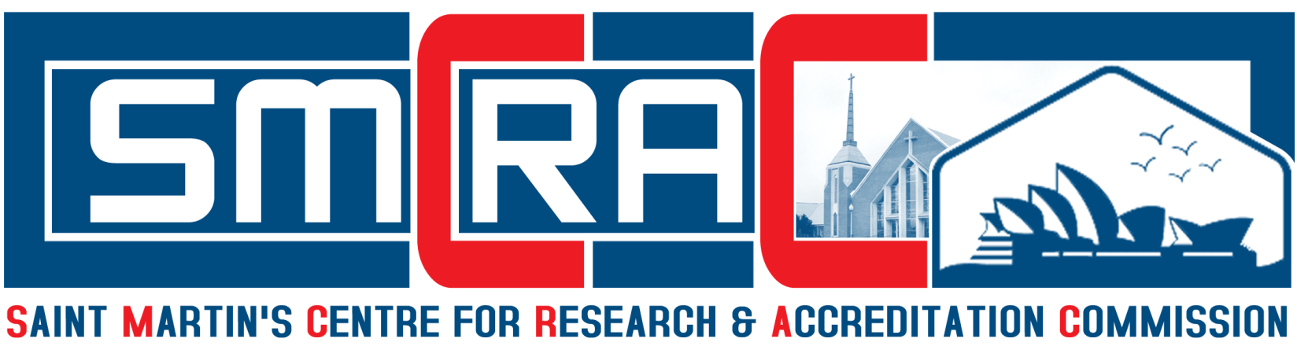
Global Professionals – Educationalist Awards & Honors Convocation 2020
Saint Martin’s Centre for Research & Accreditation Commission (SMCRAC) will be celebrated on 2020 at Australia / United States of America / India. The Awards will be present to the Winners by the Board of Directors of SMCRAC Australia / United States of America / Indian Chapter. Please submit the filled application in word, pdf (or) scan format via email to: Email: smcracoffice@gmail.com
Name of the Category | Best Researcher Award  Best Research Scholar Award  Best Senior Faculty Award  Best Young Faculty Award  Excellence Teaching in Higher Education Award  Leading Educationist of India Award  Best Director / Principal / Dean Award  Best Women Faculty Award  Award of Excellence in Research  Life Time Achievement Award  Distinguished Professor Award  Outstanding Achievement Award  Outstanding Woman Award  Young Engineer Award  Senior Engineer Award  Out Standing Engineer Award  Young Scientist Award  Senior Scientist Award  Out Standing Scientist Award  Young Researcher Award  Senior Researcher Award  Out Standing Researcher Award  Innovative Academician Award
Name of the Applicant
Gender
Date of Birth
Place of Birth
Nationality
Citizenship
Mobile Numbers
Email Ids
Address for Communication
Permanent Address
Educational Qualification
Area of Specialization
Designation
Name of the Department
Official Address
Year of Completion of Ph.D
Ph.D Registration Number
Title of Ph.D Thesis
Name of the University
Name of the Supervisor
Teaching Experience
(in Years)
Full Time Research Experience
(in Years)
Industrial Experience
(in Years)
No. of Ph.D Scholars Awarded
No of Ph.D Scholars Doing
Patents (in Numbers)
Research Grants
(in Numbers)
Research Projects
(in Numbers)
SCI Journal Publications
(in Numbers)
Scopus Journal Publications
(in Numbers)
Other Journal Publications
(in Numbers)
International Conference Publications (in Numbers)
National Conference Publications (in Numbers)
International Conference Presentations (in Numbers)
National Conference Presentations (in Numbers)
International Books Publications
(in Numbers
National Books Publications
(in Numbers)
Chapters Publications
(in Numbers)
International Training Programs Attended (in Numbers)
Resource Talk (in Numbers)
International Awards Received
(in Numbers)
National Awards Received
(in Numbers
Editorial Appointments in International Journals (in Numbers)
Editorial Appointments in National Journals (in Numbers)
No. of MOU Signed
No. of Conference / Symposium / Training Programs Organized
No. of Participation in NSS / NCC / YRC/ CCC / Others
No. of Professional Societies Membership

Declaration: I certify that the above mentioned information is correct and complete to the best of my knowledge and trust. At any time I am found to have concealed / distorted any material information, my application shall be liable to be instantly terminated without notice / compensation.

Signature of Applicant

Date:
Place:

